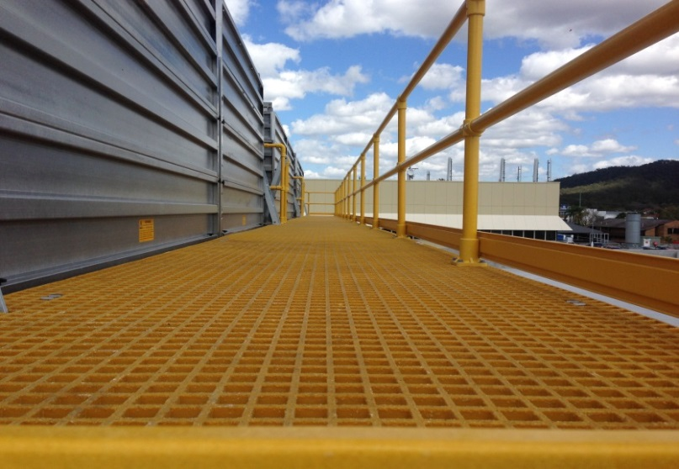
Pultrac moulded gratings are manufactured using a heated mould process. Continuous fibres are placed in the mould in alternating layers and are completely wetted out with resin. This continuous process produces an integral, one piece construction which has bi-directional strength. The addition of grit to the surface adds increase slip-resistance.

Pultrac gratings have been developed to meet the stringent quality standards of the American and European markets
Pultrac moulded grating is resistant against corrosion and chemical attack, provide a long lasting safe alternative to metal grating. Available in various dimensions and colours.

Moulded Grating - Mesh size 38 x 38 mm
Panel Size  (mm) | Thickness  (mm) | Bar Thickness  Top/Bottom | Weight  (kg/m²) | Open Area  (%)
1220x3660,1220x4000,1220x2440,  915x3050,1268x4010 | 14 | 6.0/5.0 | 6.5 | 78
1220x3660,1220x4000,1524x4010,  997x3012 | 20 | 6.0/5.0 | 9.8 | 65
1220x3660,1220x4010,1524x4010,  915x3050,1524x4000,997x3012 | 25 | 6.5/5.0 | 12.3 | 68
1220x3660,1220x4010,1524x4026,  915x3050,1524x4000 | 30 | 6.5/5.0 | 14.6 | 68
1220x3660,1220x4000,1200x2440,  915x3050,1524x4000,1524x3050,1000x4000 | 38 | 7.5/5.0 | 19.5 | 68
1220x4010,1220x3660,1220x2440,  915x3050 | 50 | 11.0/9.0 | 42 | 56
1220x4010,1220x3660,1220x2440,  1232x4010,915x3050 | 60 | 10.5/9.0 | 50.4 | 54
1230x4101 | 70 | 11.5/9.0 | 58.8 | 49

Uniform Load Deflection
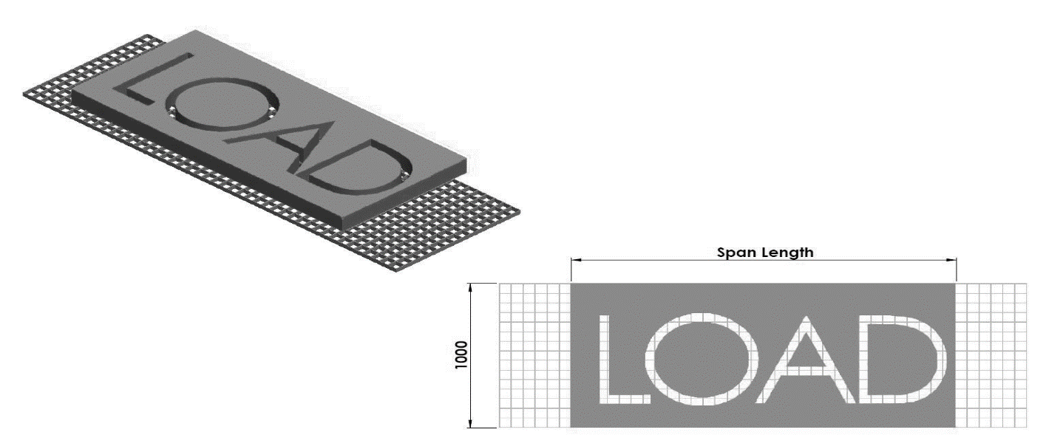

8x38x20 | Uniform load deflection Kg/m
Span (mm) | 350 | 500 | 750 | 1000 | 1500 | 2500 | Break point
300 | <0.254 | 0.254 | 0.508 | 0.508 | 1.016 | 1.524 | 29280
450 | 1.016 | 1.524 | 2.286 | 3.048 | 4.572 | 7.620 | 12980
600 | 3.084 | 4.572 | 7.112 | 9.398 | --- | --- | 7320
750 | 5.842 | 8.890 | --- | --- | --- | --- | 7084
900 | --- | --- | --- | --- | --- | --- | 3226

38x38x25 | Uniform load deflection Kg/m
Span (mm) | 240 | 480 | 980 | 1450 | 2450 | 3650
450 | 0.660 | 1.092 | 1.930 | 2.769 | 4.470 | 7.620
600 | 1.118 | 2.108 | 4.140 | 6.172 | 10.211 | ---
750 | 2.667 | 5.387 | 10.820 | 16.280 | --- | ---
900 | 5.537 | 11.176 | 21.717 | --- | --- | ---

38x38x30 | Uniform load deflection Kg/m
Span (mm) | 350 | 500 | 750 | 1000 | 1500 | 2500 | Break point
300 | <0.254 | <0.254 | <0.254 | <0.254 | 0.254 | 0.508 | 32500
450 | 0.254 | 0.508 | 0.762 | 1.016 | 1.524 | 2.286 | 21661
600 | 1.060 | 1.524 | 2.286 | 2.794 | 4.318 | 7.366 | 12980
750 | 2.540 | 3.810 | 5.842 | 7.620 | 11.684 | --- | 8296
900 | 4.572 | 7.112 | 10.668 | --- | --- | --- | 5758

38x38x38 | Uniform load deflection Kg/m
Span (mm) | 240 | 480 | 1450 | 2450 | 3650 | 4880
300 | 0.254 | 0.305 | 0.381 | 0.457 | 0.635 | 0.838
600 | 0.432 | 0.813 | 1.549 | 2.311 | 3.835 | 5.740
900 | 1.702 | 3.454 | 6.659 | 10.465 | 17.475 | ---
1200 | 5.969 | 12.167 | 24.511 | --- | --- | ---

Line Load Deflection
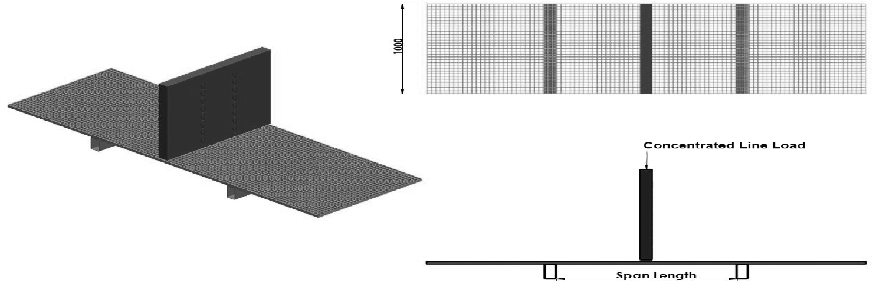

38x38x20 | Line load deflection Kg/m
Span (mm) | 75 | 150 | 300 | 450 | 750 | Break point
300 | 0.254 | 0.508 | 1.016 | 1.524 | 2.540 | 4470
450 | 0.762 | 1.524 | 3.302 | 4.826 | 8.128 | 2980
600 | 1.778 | 3.810 | 7.620 | 11.176 | --- | 2235
750 | 2.794 | 5.588 | 11.430 | --- | --- | 1788
900 | 5.334 | 10.668 | --- | --- | --- | 1490

38x38x25 | Line load deflection Kg/m
Span (mm) | 75 | 150 | 300 | 450 | 600 | 750 | Break point
450 | 0.559 | 1.146 | 2.159 | 3.073 | 4.115 | 4.75 | 3910
600 | 0.864 | 1.702 | 3.505 | 5.156 | 6.706 | 8.179 | 2924
900 | 2.896 | 5.918 | 12.116 | 18.440 | --- | --- | 1948
1200 | 5.715 | 111.633 | --- | --- | --- | --- | 1461

38x38x30 | Line load deflection Kg/m
Span (mm) | 75 | 150 | 300 | 450 | 600 | 750 | Break point
300 | <0.254 | <0.254 | 0.254 | 0.805 | 0.762 | 1.524 | 9923
450 | 0.254 | 0.508 | 1.016 | 1.524 | 2.540 | --- | 4827
600 | 0.508 | 1.270 | 2.286 | 3.556 | 5.842 | --- | 4112
750 | 1.270 | 2.540 | 4.826 | 7.366 | 12.446 | --- | 3173
900 | 1.778 | 3.810 | 7.620 | 11.430 | --- | --- | 2637

38x38x38 | Line load deflection Kg/m
Span (mm) | 75 | 150 | 300 | 450 | 600 | 750 | Break point
300 | 0.279 | 0.365 | 0.483 | 0.610 | 0.762 | 0.889 | 17116
600 | 0.356 | 0.660 | 1.245 | 1.850 | 2.464 | 3.073 | 8718
900 | 0.864 | 1.803 | 3.683 | 5.563 | 7.417 | 9.296 | 5817
1200 | 2.261 | 4.749 | 9.677 | 14.630 | 19.583 | --- | 3755

